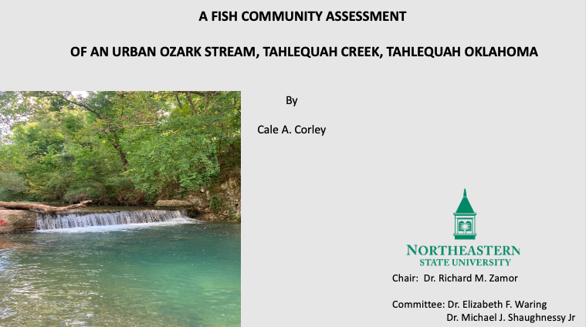

Wednesday November 30th at 4:15 PM
Tahlequah: SC 147

Zoom Meeting
https://nsuok.zoom.us/j/98947575484
Meeting ID: 989 4757 5484

